New Remote Login Facility

From v2.4.4.12 The ZFP Tools support remote login.
When data is sent to the panel or retrieved from the panel the panel must be logged in at access level 3.
There were timing problems, and it can be inconvenient so the latest version of firmware and tools support remote login, which allow you to log in at access level 3 from the PC.
When you try to send or retrieve data, the first screen you will see on the PC is this
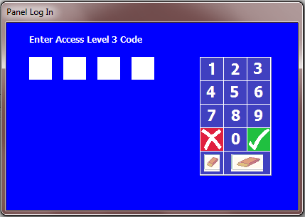
This is visually very similar to what you see on the panel, and deliberately so top make its purpose obvious.
You may enter the password via key pad or you can type the password directly. Only numbers, Enter, Esc, backspace and Ctrl-C are recognised, as follows:
 to  can be ‘pressed’ using keyboard digits 0-9.
 or Esc key abort the input (and transmission).
 or Enter key sends the password entered to the panel, and, if successful, starts transmission.
 or backspace deletes the last entered digit of the password
 or Ctrl-C erased the entire password and allows it to be re-entered from the start.
Backwards compatibility
Old panels do not support this feature and you must log in at the panel. You can either log in in advance (you must still log in as above) or log in as above in which case the panel will beep 3 times and present the login screen.
You will also see the following screen on the PC
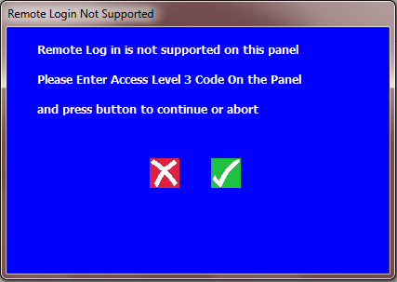
When you enter the correct PIN on the panel this screen will automatically disappear. Pressing the  or Esc button aborts the transfer.

